**COUNTRY REPORT**

**introduction**

County Report on Education system in Rwanda is prepared by PACIFIQUE IKIREZI from Rwanda Country, Eastern province Nyagatare District Gatunda Sector at ETP NYARUREMA SCHOOL.

The main purpose of this report is to share the findings with other participants who will participle the Capacity Development for Master Teacher and Clinical Supervision for ICT in Education (Rwanda) online training and Korea experts in an effort to provide solutions to the identified problems and issues for Rwanda.

## History of Rwandan education after 1994

Post-genocide years focused on human capital rebuilding and increasing enrolment rates. 1996 saw the introduction of 6-year primary, 3-year lower secondary, and 3-year upper secondary education, where Kinyarwanda was the language of teaching up to 6-year primary, whereas lower and upper secondary, which changed to French and English.

In 2006, The 4th Education Sector Strategic Plan (ESSP 2006–2010) introduced fee-free schooling for 9YBE - 9 Year Basic Education, later to 12 YBE - including primary and lower secondary. While enrolment rates have gone up, school related costs remain a barrier for many.

In 2008, in an effort to stimulate Rwanda's integration with the East African Community (EAC), English was adopted as the national teaching language, and now the instruction language is English.

Several new authorities were created:

* The **Workforce Development Authority (WDA)** was created in 2008 to address the growing need for better, more, and more demand-driven policy for technical and vocational training. Later in 2021 replaced by RWANDA TVET Board.
* The **Rwanda Education Board (REB)**, established in 2011, became the implementing agency for general education: giving education policy input on sciences, coordinating implementation of education programs, overseeing curriculum development, education standards, national examinations for sciences, etc. Now the national Examination and School Inspection (NESA) was put in place in 2021.
* The Rwanda polytechnic was created in February 2018 encompasses all integrated polytechnic regional center (IPRC), became the implementing agency for technical education standards, technical and vocational national examinations, etc.

Since 2012, under the new Education Sector Strategic Plan (ESSP 2013-2015), focus has shifted from increasing 9YBE access and enrollment to improving quality and relevance of schooling as well as increasing access to secondary level schooling with the introduction of the 12 Year Basic Education (12YBE) policy, making schooling fee-free up to upper secondary.

Brief indication of post Pre_Primary education

|  |  |  |  |  |  |
| --- | --- | --- | --- | --- | --- |
| Education | School/Level | Grades | Age | Years | Notes |
| Primary | Primary Education | 1-6 | 6-12 | 6 |  |
| Middle | Lower Secondary | 7-9 | -18 | 3 |  |
| Secondary | Secondary Education | 10-12 |  | 3 |  |
| Post-Secondary | Post-secondary Diploma |  |  | 1-3 | Certificate of Higher Education: 1 year Diploma in Higher Education: 2 years Advanced Diploma in Higher Education |
| Tertiary | Bachelor |  |  | 3-5 |  |
| Tertiary | Master |  |  | 1-2 |  |
| Tertiary | Doctorate |  |  | 3 | PhD |

**2. Describe the TVET system in Rwanda**

## 2.1: Describe the historical background of the Rwanda TVET system

TOPIC 1:The historical background of TVET

**Rwanda National context**

Technical and vocational training was provided by different institutions with different naming.

* Before 1979:
  + Ecole familiales: Offering vocational training for female graduates of primary school for 2 years
  + CERAR: Centre d’enseignement rural et artisanale: : Offering vocational training for male graduates of primary school for 2 years
  + 1980-1994 : CERAI: Centre d’enseignement rural artisanal intégré :

 Former Ministry of education ‘’MINEPRISEC’’ had developed a network of centers, managed by the district or by religious institutions;

Enrolled pupils from primary not eligible for secondary education.

Training duration was 2years.



* + Before 1979-2009: École officielle technique ( ETO):
* Initially 4 École officielle technique ( ETO) namely ETO Kicukiro, ETO Kibuye, ETO Kibungo, ETO Gatumba supervised by MINISTRY OF Education, offered technical education and award A3 and A2 certificates.

 After 1994, other three ETO were created namely ETO Nyamata and ETO Gitarama, ETO Muhima

* + 1980-2009 : CFJ : Centre de Formation des Jeunes



Supervised by the Ministry of Youth, Sports, Culture and Vocational Training

Transformed into VTC when WDA was established

 Offered short course training of 6 months to 1year in different trades such as masonry, carpentry and Tailoring.

* + 2009-2017: WDA, VTC, TSS, IPRCS

 Workforce development authority (WDA):

➢ In 2008, the Government of Rwanda initiated Workforce Development Authority as an institutional framework to provide a strategic response to the skills development challenges facing the country across all sectors of the economy with the following mandates

 Established by the law no 03/March/2009 and restructured by the law no Nº42/2016 of 18/10/2016

* In 2013 new competency based curricula were developed and piloted in Southern Province, Rwanda TVET qualification framework elaborated.

 Vocational training centers (VTC) and Technical secondary school (TSS): After the establishment of WDA, the supervision of CFJ shifted from the Ministry of youth, sport and culture to the ministry of education. Then, the name changed to VTC, and all secondary schools offering vocational courses become technical secondary schools (TSS).

* Integrated polytechnics regional centers ( IPRCs):

 In 2007, Tumba College of technology were established in Northern Province in Rulindo District.

 Five IPRCS we established in 2008, namely IPRC Kigali, IPRC EAST, IPRC WEST which inherited the existing physical infrastructures of ETO in their respective provinces.

All IPRCs were under the supervision of WDA but since 2018 after the implementation of new restructuring of WDA, IPRCs are under supervision of Rwanda polytechnic ( RP) .



 0n 28 February 2018, Gishali Integrated College were established in Eastern Province, Rwamagana District.

* 2018: Rwanda polytechnic( RP):

 In 2017, after Education sector reform, Rwanda Polytechnic (RP) is established by the law Nº 21 bis/2017 of 28/04/2017 but become operational since March, 2018.

## 2.2: Interpret TVET overall guidelines

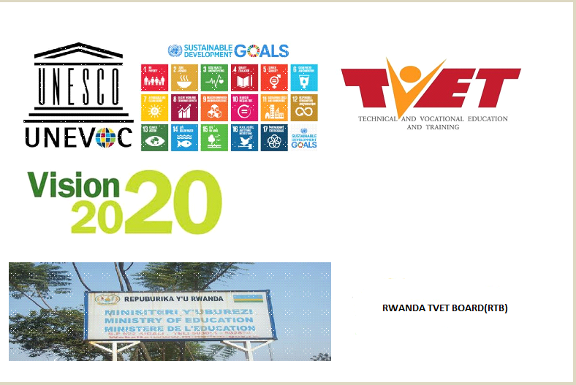

**Key concepts:**

**UNESCO strategy for TVET**

|  |
| --- |
|  |

UNESCO Strategy for Technical and Vocational Education and Training (TVET) 2016-2021 aim:

* + To support the efforts of Member States to enhance the relevance of their TVET systems and to equip all youth and adults with the skills required for employment, decent work, entrepreneurship and lifelong learning.
  + To contribute to the implementation of the 2030 Agenda for Sustainable Development as a whole.
* **SDGS: Sustainable Development Goals**

The 17 sustainable development goals (SDGs) to transform our world:

[GOAL 1: No Poverty](https://www.un.org/development/desa/disabilities/?page_id=6226&preview=true)

[GOAL 2: Zero Hunger](http://www.un.org/development/desa/disabilities/envision2030-goal2.html)

[GOAL 3: Good Health and Well-being](http://www.un.org/development/desa/disabilities/envision2030-goal3.html)

[**GOAL 4: Quality Education**](http://www.un.org/development/desa/disabilities/envision2030-goal4.html)

[GOAL 5: Gender Equality](http://www.un.org/development/desa/disabilities/envision2030-goal5.html)

[GOAL 6: Clean Water and Sanitation](http://www.un.org/development/desa/disabilities/envision2030-goal6.html)

[GOAL 7: Affordable and Clean Energy](http://www.un.org/development/desa/disabilities/envision2030-goal7.html)

[**GOAL 8: Decent Work and Economic Growth**](http://www.un.org/development/desa/disabilities/envision2030-goal8.html)

[GOAL 9: Industry, Innovation and Infrastructure](http://www.un.org/development/desa/disabilities/envision2030-goal9.html)

[GOAL 10: Reduced Inequality](http://www.un.org/development/desa/disabilities/envision2030-goal10.html)

[GOAL 11: Sustainable Cities and Communities](http://www.un.org/development/desa/disabilities/envision2030-goal11.html)

[GOAL 12: Responsible Consumption and Production](http://www.un.org/development/desa/disabilities/envision2030-goal12.html)

[GOAL 13: Climate Action](http://www.un.org/development/desa/disabilities/envision2030-goal13.html)

[GOAL 14: Life below Water](http://www.un.org/development/desa/disabilities/envision2030-goal14.html)

[GOAL 15: Life on Land](http://www.un.org/development/desa/disabilities/envision2030-goal15.html)

[GOAL 16: Peace and Justice Strong Institutions](http://www.un.org/development/desa/disabilities/envision2030-goal16.html)

[GOAL 17: Partnerships to achieve the Goal](http://www.un.org/development/desa/disabilities/envision2030-goal17.html)

✓ The education sector focus on SDG 4 and SDG8

 **SDG 4 “**[**Quality Education’**](http://www.un.org/development/desa/disabilities/envision2030-goal4.html)**’** Particularly related to TVET, SDG 4, among other things, calls on Member States to ensure equal access to TVET programmes, to substantially increase the number of youth and adults with relevant skills for employment, decent jobs and entrepreneurship, and to eliminate gender disparities in education.

 **SDG 8**” **Decent Work and Economic Growt**[**h’**](http://www.un.org/development/desa/disabilities/envision2030-goal8.html)**’** Aims to “promote inclusive and sustainable economic growth, employment and decent work for all”. Such holistic visions challenges TVET to expand quality skills provisions and ensure skills relevance not only for the world of work, but also to support lifelong learning, inclusion and economies’ and societies’ low-carbon transitions.

• **Vision 2020:**

* Vision 2020 was Rwanda’s long-term development plan adopted in 2000 that seeks to fundamentally transform Rwanda into a middle-income country by 2020.
* The expected outcome of the vision was a united Rwanda that is competitive both regionally and globally.
* Emphasizes skills development as an essential pre‐condition for sustainable economic growth and a comprehensive human resources development is considered to be necessary for achieving middle income status.
* Vision 2020 **Pillars** were:

**Pillar 1**: Good Governance and a Capable State

**Pillar 2: Human Resource Development and a knowledge based economy**

**Pillar 3: Private led Development**



**Pillar 4**: Infrastructure Development

**Pillar 5**: Productive high value and market oriented agriculture

**Pillar 6**: Regional and International Integration

* Vocational Education focuses more **on pillar 2 and 3** andplays an important role in Vision 2020 process helping the country make the transition towards a *"knowledge‐based economy".*
* **National Strategic Transformation** 
  + **Is an implementation instrument of** EDPRS 2 (2013-2018), Vision 2020, Vision 2050, Sustainable Development Goals (SDGs), African Union’s Agenda 2063 as well as the East African Community’s Vision 2050.
  + The National Strategy for Transformation is built on 3 pillars:

Economic Transformation,

Social Transformation,



Transformational Governance.

* + The overarching goal for the **Social Transformation Pillar** is to Develop Rwandans into a capable and skilled people with quality standards of living and a stable and secure society.
  + The Social Transformation Pillar has 5 broad objectives;

Move towards a Poverty Free Rwanda.

Ensure a Quality Healthy Population



Develop a Competitive and Capable Rwandan Population

Ensure Quality of education for all aiming at building a knowledge-based economy

Transition to a Modern Rwandan Household in urban and rural areas

* **Economic Development and Poverty Reduction Strategy**, **EDPRS II** (**2013-2018)**
  + - The Economic Development and Poverty Reduction Strategy (2013-2018), stems from Rwanda’s Vision 2020 and guides medium term actions that will lead to the achievement of the Vision’s goals.
    - The main goal of the strategy is to speed up Rwanda’s progress towards becoming a middle-income status country and creating a better quality of life for all Rwandans through sustained average GDP growth of 11.5% and accelerated poverty reduction to less than 30% of the population.
    - EDPRS II thematic areas were:

Economic Transformation

Rural Development



**Productivity and Youth Employment**

Accountable Governance

The TVET focus more on thematic area number 3: Examples of issues to be addressed for the thematic area 4 are **Productivity and Youth Employment**

**Education Sector Strategic Plan (ESSP) :**

✓ Elaborates on how the education sector will strive to achieve its mission and provides the foundation for education sector planning for the next five years

✓ three (3) overarching goals:

Promoting **access** to education at all levels,



Improving the **quality** of education and training, and

Strengthening the **relevance** of education and training to meet labour market demands.

The ESSP provides a framework for continuous development of the national education system by identifying priority investment areas to improve learning outcomes and increase educational relevance for a globally competitive Rwandan workforce.

• **TVET Policy**:

* + - First TVET policy is established in April 2008 ended in 2015 and the revised TVET policy is established in September 2015. And today in 2021 there is another revision.
    - The vision of the revised TVET system in the light of new demands and constraints facing TVET, particularly with regards to the need to create employability skills and the recent establishment of Rwanda TVET qualification framework.
    - The implication of the new policy environment for TVET, particularly in relation to the country, new education sector strategic plan, the economic development and poverty reduction strategy( EDPRS), National employment programmes, the new national gender policy and the girl’s education policy.
    - The constraints facing the TVET system and what areas need to be reformed.

**• Workplace Learning** (WPL**) policy:**

* + The vision of the Workplace Learning Policy is to unleash Rwanda’s potential of workplace training and learning through the development of modern apprenticeship training, and increased internship and attachment opportunities, in order to ensure that skills development for new labour market entrants responds to the needs of the labour market and assists an increasing number of Rwandan youth to find employment and participate in the country’s development.
  + The mission of the policy is to nurture and facilitate the development of workplace learning systems in Rwanda that are owned and driven by employers/industry, adequately respond to the skills needs of the growing Rwandan economy and provide an avenue towards formal qualifications recognized on the Rwandan National Qualifications Framework.
  + The efforts to strengthen workplace learning respond to an increasingly widespread emphasis in the Rwandan policy framework to deepen the linkages of the education sector with the world of work, and to increase the relevance of skills development through stronger partnerships with enterprises.

## 2.3: Describe Rwanda TVET System governance

TOPIC 1:TVET institutions structures and mandate

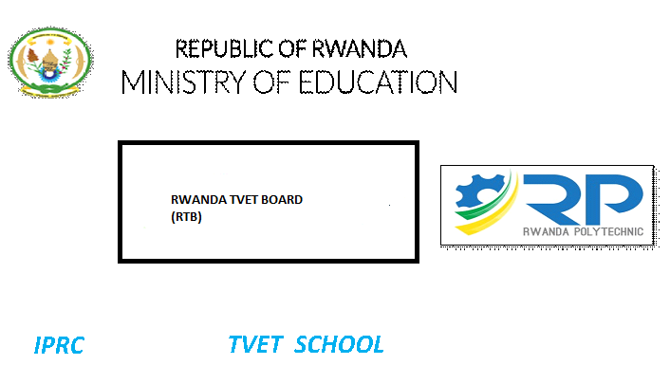

**TVET Governing institutions**

• **Ministry of Education (MINEDUC)**

|  |
| --- |
|  |

* The general mission of the Ministry of Education is to transform the Rwandan citizen into skilled human capital for socio-economic development of the country by ensuring equitable access to quality education focusing on combating illiteracy, promotion of science and technology, critical thinking and positive values.
* The general mandates of Ministry of Education are:

 Developing, reviewing and guiding the implementation of education sector policies and strategies geared towards achieving vision 2020 through the elaboration, dissemination and coordination of the implementation of education sector policies, strategies and programs regarding basic education, post basic and higher education, literacy, special programs and information and communication technology in education;

 Developing laws and adopting regulations and guidelines for the promotion of education in line with national education policy through:

* Reporting periodically and annually to the Government on the impact of the education policies, programs, strategies and programs on the development of the education sector;

Developing strategies for resource mobilization and efficient utilization through:

Promoting the teaching, learning and the good use of information and communication in education through:



 Developing, reviewing and guiding education sector for institutional development and capacity building through

✓ **The Ministry of education structure:**

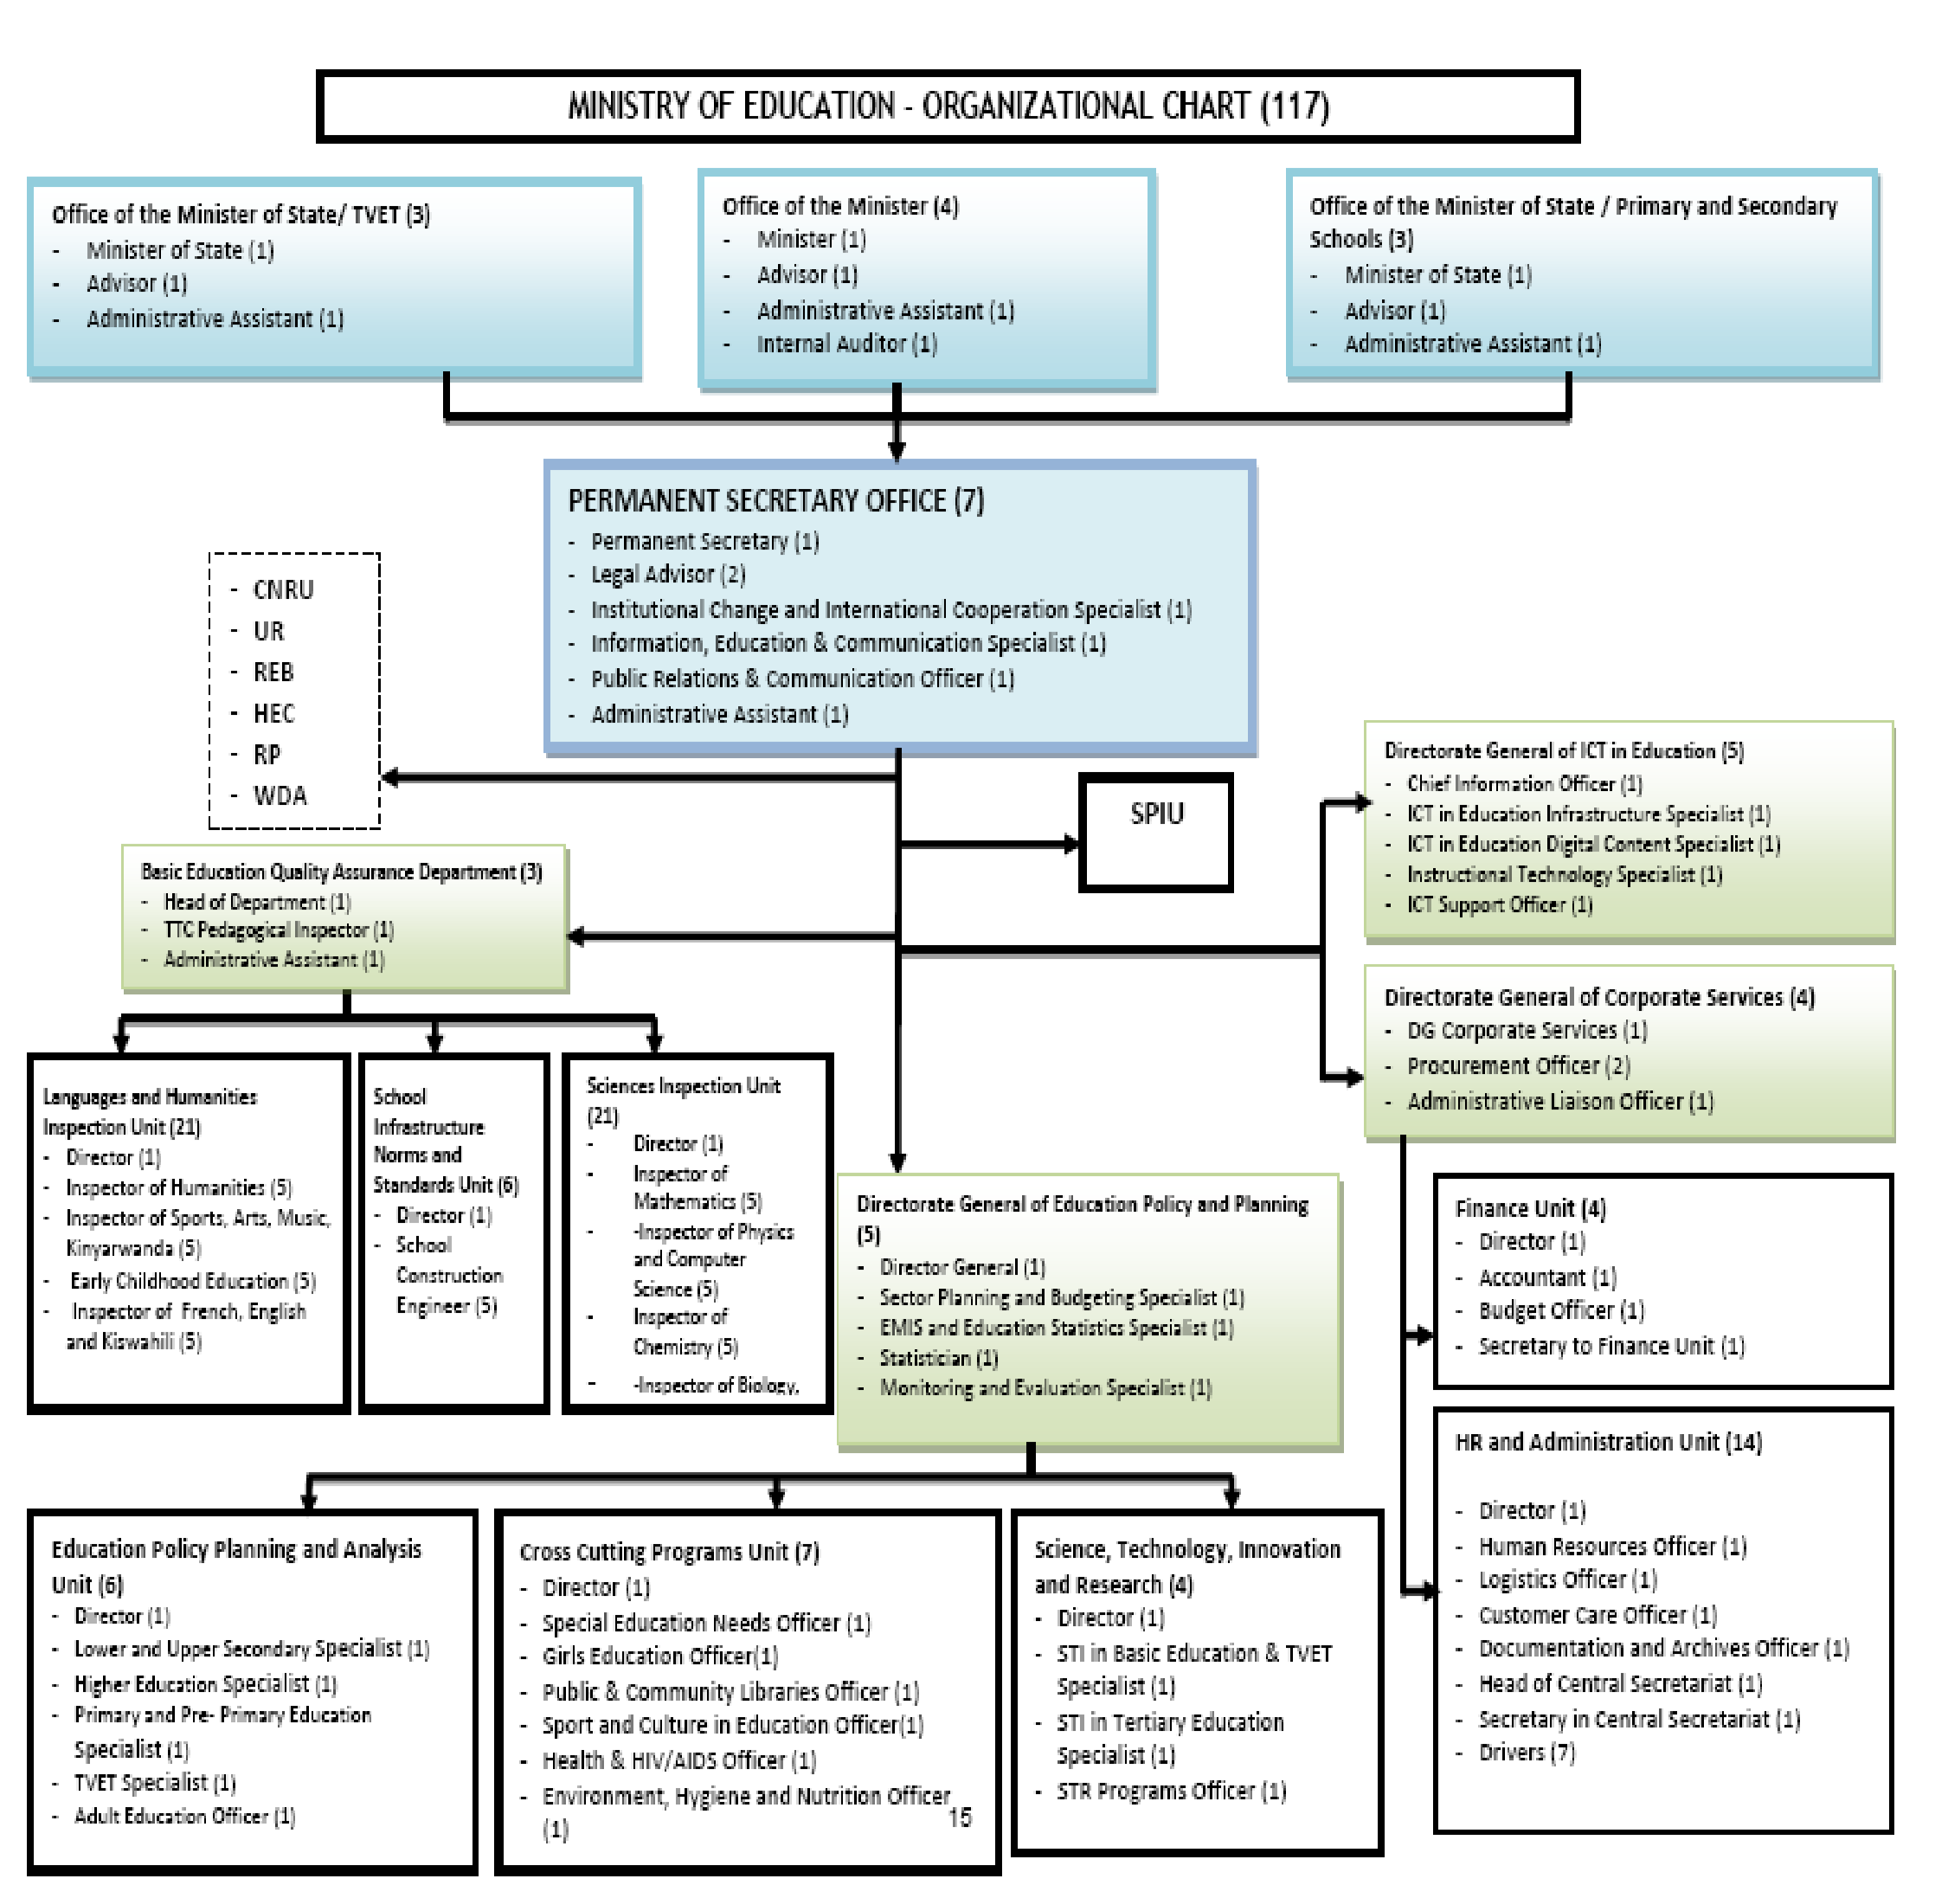

 **Rwanda Polytechnic (RP):**



✓ Is located in Kicukiro District, Niboye sector

✓ RP mandate is:

 To prepare curricula for their use at various technical and vocational training levels and submit them to the competent authority for approval; To offer TVET courses leading to certificate or diploma;

To provide science- and technology-based technical and vocational training as well as education which enable the beneficiary to create jobs for personal development and contribute to national development;

 To carry out and promote research and technology in technical and vocational fields and disseminate their findings to foster national development;

 To participate in the discovery, exchange and preservation of knowledge in technical and vocational field;

To promote education, culture and Rwandan values;



To impart knowledge required to provide technical and vocational education and apprenticeship training;

 To offer in-service training to practitioners in various fields to develop their technical and vocational skills;

 To coordinate programmes and activities aimed at developing teaching and research staff within institutions of TVET, upgrade their knowledge and skills capacities and improve their management;

To contribute to finding solutions to other problems related to national development;

To cooperate and collaborate with other national, regional or international institutions with similar mission in order to achieve its mission.



✓ **RP structure:**

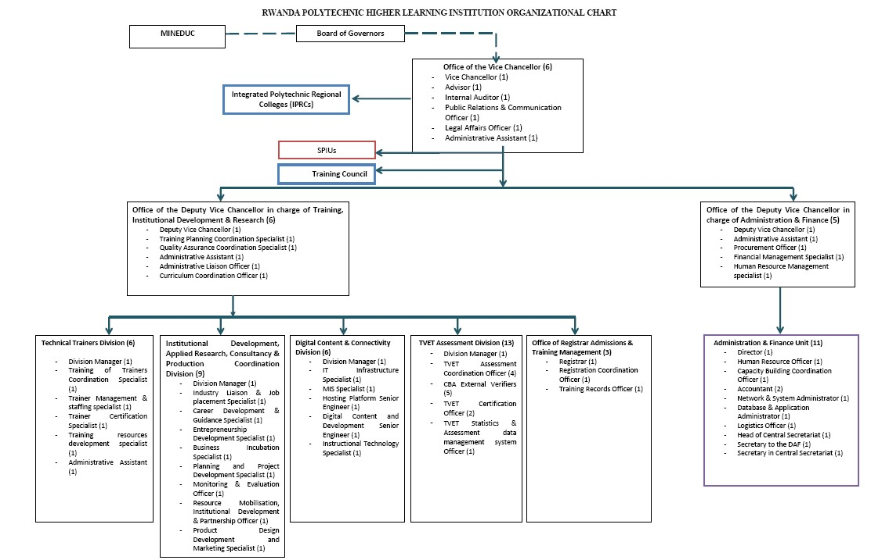

19 | P a g e

 **Integrated Polytechnic Colleges (IPRCs)**

* Located at provincial level, eight in total: IPRC Kigali, IPRC Huye, IPRC Ngoma, IPRC Musanze, IPRC Tumba, IPRC Gishali, IPRC Karongi and Kitabi College ……..
* Under direct supervision of RP
* IPRCs structure



 **Integrated Polytechnic Colleges ( IPRCs)**

Today’s TVET and polytechnics per province:

West: 76 TVET and 1 Polytechnic

East: 75 TVET and 2 Polytechnics

South: 88 TVET and 3 Polytechnics

North: 63 TVET and 3 Polytechnics

Kigali: 63 TVET and 5 Polytechnics

Rwanda has the Target of building at least 54 TVET schools each year up to 2024 where 60% of students will be in TVET schools.

* Under direct supervision of RP
* IPRCs structure :

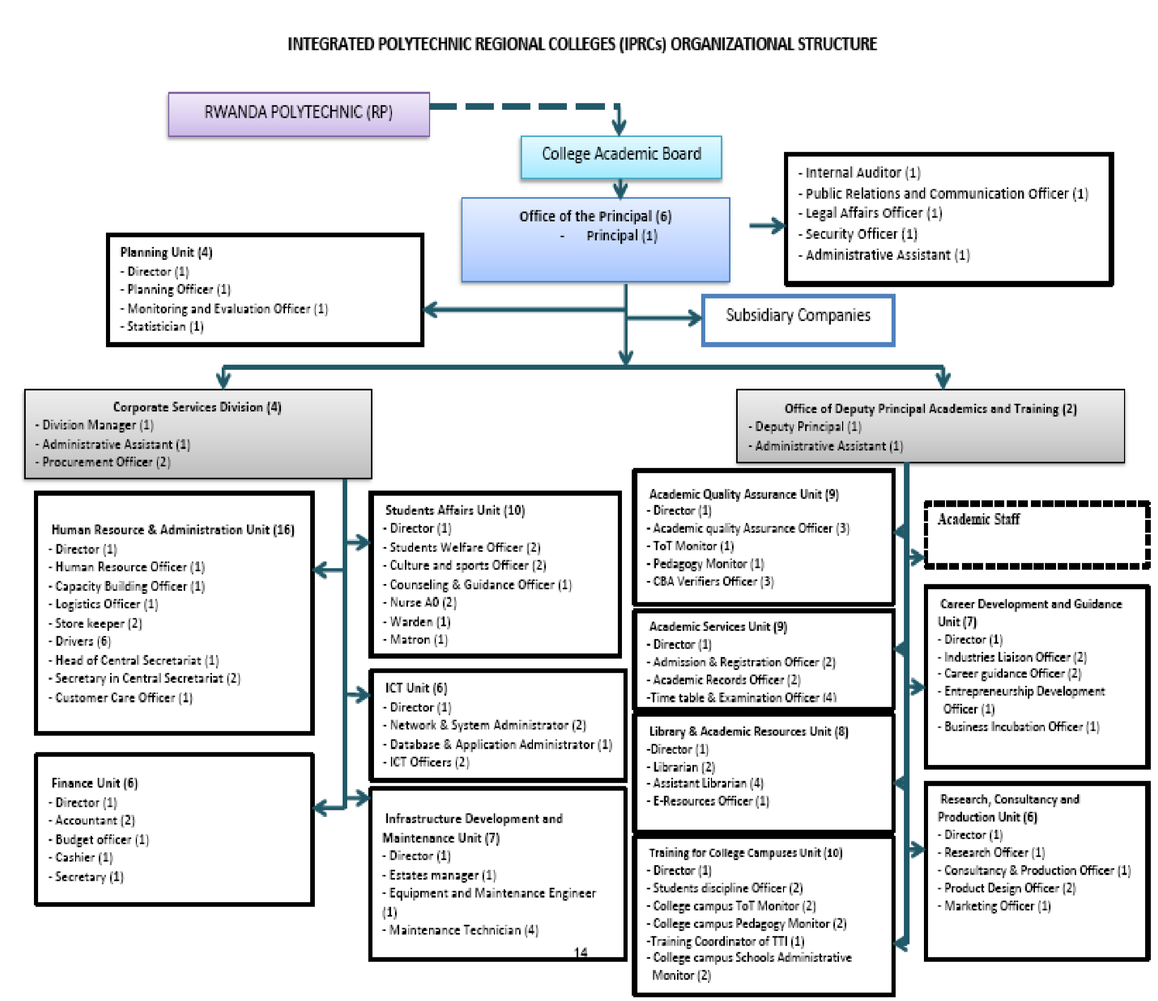

**2.4: Education during COVID-19 pandemic**

2.4.1. IntroductionOn 31 December 2019, the Government of China reported a cluster of cases of pneumonia of unknown cause in Wuhan, Hubei Province. A new coronavirus was eventually identified. On 30 January 2020, the Director-General of World Health Organisation (WHO) declared the coronavirus disease 2019 (COVID-19) outbreak a Public Health Emergency of International Concern (PHEIC) under the International Health Regulations (IHR) 2005. On 11 March WHO declared COVID-19 a pandemic.  
As of 24 March 2020, cases have been reported in 195 countries. On 14 March 2020, the first confirmed case of coronavirus was declared in Rwanda.  
Subsequently, the Government demonstrated high-level leadership and swift action to tackle the risks associated with the ongoing pandemic and implemented school closures effective 16 March 2020. Day scholars immediately remained at home and boarding school students were facilitated to return to their respective homes. As of 18 March 2020, the process of returning boarding school students was completed.  
As of 21 March 2020, the Government further implemented measures to minimise risk of transmission including border closings and stringent social distancing policies including closing schools, colleges, churches, and bars; mandating home-based work except for critical services; and banning motorcycle drivers from carrying passengers. This was to be in effect until April 19, 2020 when the situation was evaluated to inform future decisions.  
In Rwanda an estimated 3,574,070(EMIS, 2018) students is out of school due to the lockdown. If this situation is permitted to continue unabated, it could have profound long-term negative impacts on the country’s development.  
Following the WHO recommendations to stop the human-to-human transmission of COVID-19, the Republic of Rwanda developed a national COVID-19 Preparedness and Response Plan. The Government, supported by the donor community, has put together an Education Sector COVID 19 Response Plan, which aligns with the National COVID-19 Preparedness and Response Plan.The Education Sector COVID-19 Response plan was developed by the Ministry of Education, in consultation with its agencies and other Ministries and in support of Development Partners.

2.4.2. RationaleThe Education Sector COVID-19 Response Plan works to elaborate upon the Government of Rwanda National Preparedness and Response COVID-19 Plan, with specifics for the Education Sector. This Education Sector COVID Response Plan also aligns with the Education Sector Strategic Plan (ESSP) (2018/19–2023/24) to work towards ensuring Rwanda’s aspirations for transformation from a predominantly agrarian-based, low-income economy to an industrial, knowledge-based middle-income nation by 2020.

This plan is premised on the ability of Rwanda’s education system to respond and adapt to the COVID-19 situation. The impact of this response plan is to ensure that the goal of the ESSP is realised: ***to ensure Rwandan citizens have sufficient and appropriate skills, competences, knowledge and attitudes to drive the continued social and economic transformation of the country and to be competitive in the global market.***The Ministry of Education (MINEDUC) assumes the lead responsibility for policy formulation, educational planning, coordination and M&E at the national level, and is the lead Ministry for the education sector, with responsibility for policy formulation, coordination and regulation through setting norms and standards for the education sector.  
MINEDUC’s mission is *to transform Rwandan citizens into skilled human capital for the socio-economic development of the country by ensuring equitable access to quality education, focusing on combating illiteracy, promotion of science and technology, critical thinking, and positive values*.  
MINEDUC works closely with other Ministries, for a cross-sectoral approach, and oversees the work of the semi-autonomous Government agencies at central and decentralised levels, including the Rwanda Education Board (REB), the Rwanda TVET Board (RTB), National Examination and School Inspection (NESA), the Rwanda Polytechnic (RP), the Higher Education Council (HEC), the University of Rwanda (UR) and the National Commission for UNESCO (CNRU).  
This Education COVID-19 Response Plan provides the overarching framework for a holistic sector-wide approach to the development and delivery of education services in Rwanda. It also serves as a guiding framework for the elaboration of sub-sector educational plans. It also works to build cross-sectoral integration and will work alongside other Government Ministries, civil society, and development partners for its realisation.  
The Education COVID-19 Response Plan provides the overarching and guiding framework, budget, and monitoring and evaluation framework.

2.4.3**. Education COVID Response Plan**2.4.3**. 1. Goal**  
To support continuation of quality learning while protecting the health and well-being of approximately  
3.6 million students and an estimated 96,000 teachers targeted under the parent project in the short,  
medium, and long term.  
2.4.**3.2** **Objectives**  
The objectives of the Education COVID-19 Response Plan align with the objectives of the National  
Preparedness and Response Plan of the Government of Rwanda:  
• Facilitate coordination of preparedness and response efforts for COVID-19 impact on the  
education sector in Rwanda, ensuring inter-sectoral and intra-sectoral coordination, engagement,  
and partner participation,

• Mobilise internal and external resources for an effective implementation of the Education Sector  
COVID-19 Plan, based on potential risks,  
• Enhance national capacities for planning, implementation, and monitoring of education activities  
throughout the situation,  
• Create and raise public awareness for engagement on COVID-19 education activities, ensuring  
other stakeholder engagement, including parents,  
• Ensure and facilitate the health and well-being of students, teachers, and education stakeholders,  
And, they was:

|  |  |
| --- | --- |
| **Objective 1:** | Ensure continuity of learning for all students in Rwanda |
| **Objective 2:** | Ensure that schools reopen with appropriate services and measures in place and that students re-enter the formal education system |
| **Objective 3:** | Ensure the health and safety of students, teachers, and other education personnel |
| **Objective 4:** | Protect and provide for vulnerable populations, including children with disabilities, girls, and children from lower wealth-quintiles |
| **Objective 5:** | Prepare the resilience of the education system against future shocks |

## Part 1: Short-Term Response

The short-term response plan covers the period of the school closures. At the time of the development of the plan this date was estimated at 20 April 2020, but may be extended, upon the decision of the Government of Rwanda based on the COVID-19 situation within Rwanda, at that time.

Objective 1: Ensure continuity of learning for all students in Rwanda

The COVID-19 pandemic has resulted in unprecedented school closures and is disrupting learning for millions of children and young people in Rwanda.

To ensure continuity of learning during school closures, the Government of Rwanda, along with its partners, engaged several remote learning programmes.

The remote learning opportunities will span three broad initiatives:

1. Radio lessons
2. Audio-visual lessons, primarily through television broadcasting
3. E-learning

*Table 1: Household access to basic technology and devices in Rwanda*

|  |  |  |
| --- | --- | --- |
| Basic technology/device utility | Percentage of HH in 2014 EICV4 | Percentage of HH in 2018 EICV5 |
| Radio | 59.8 | 73.8 |
| Mobile phone | 63.7 | 66.9 |
| Internet | 9.3 | 17.2 |
| Television | 9.9 | 10.4 |

* 1. **Radio lessons**

Radio coverage in Rwanda is over 90% with almost 80% of the households having access to a radio and is a comparative, low-budget option to reach the largest number of children. Radio-based education is relevant across the life cycle. It is feasible to develop and take to scale a core radio package that supports continuity of learning coupled with the development and dissemination of critical health promotion messages for children and young people at different stages (early years, primary, secondary levels).

To that end, radio lessons will be scripted with technical support from various Government agencies and leverage partnerships for the production and broadcasting throughout Rwanda. The medium of instruction in the radio lessons will follow the national system, whereby Kinyarwanda will be the medium of instruction for Nursery and Lower Primary levels, while English will be the medium of instruction for all other grade levels (except, of course, in specific language courses).

* 1. **Audio-Visual Lessons**

TV-based education has the potential to improve learning outcomes at all levels due to the ability to visually and audibly demonstrate learning activities.

Notably there are additional challenges in audio-visual lessons in that it is relatively more expensive with comparatively less reach.

But it is envisioned that audio-visual material will complement and enhance other remote learning opportunities. And, priority for lessons on television will be for subjects in which it is more desirable to have visual content, for example, science experiments.

* 1. **E-learning**

The Ministry of Education (MINEDUC) will work alongside the Ministry of ICT (MINICT) and various service providers to enable free access to education content on e-learning portals of REB (elearning.reb.rw), University of Rwanda (elearning.ur.ac.rw), and Rwanda Polytechnic (elearning.rp.ac.rw), amongst others to support remote learning by basic education students, tertiary, and TVET students.

Rwanda Education Board (REB) has a functional e-learning platform that is being used for sharing learning resources and materials for teachers and students. It is already in the plans of the Government and development partners to strengthen the platform.

To that effect, this plan will align with Rwanda’s ICT in Education policy that promotes ICT to increase access to education, ensuring not only the hardware, but also the digital content that is aligned to the curriculum is required to support teaching and learning that brings in 21st century skills, namely communication, collaboration, creativity and critical thinking.

**Subjects for Remote Learning**

**Pre-Primary Level:**

* N1 – N3: Numeracy, Discovery of World, Kinyarwanda, Creative Art and Culture, Language and Literacy, Social and Emotional Development.

**Primary level: All examinable/core subjects**

* P1-P6: Social and Religious Studies, Kinyarwanda, Science and Elementary Technology, and English and Mathematics

**Lower Secondary level (S1-S3): All examinable/core subjects in national examination**s

* Mathematics, Biology, Chemistry, Physics, Geography, History Entrepreneurship, English, French, Kinyarwanda, ICT, Literature, Swahili and Computer Science.

**Upper Secondary Level: All examinable/core subjects**

* **Humanities**: Geography, History, General studies, Economics, Entrepreneurship
* **Languages**: French, Kiswahili, Kinyarwanda, Literature in English
* **Sciences**: Physics, Chemistry, Biology, Mathematics, Computer Science
* **TTCs:** Foundations of Education, SST, Integrated Science, Languages

All radio and other multi-media material developed during the school closure period to support remote learning will be owned by the Ministry of Education and/or its agencies for future usage.

To support learning and to monitor update, a helpline will be created for parents, students, and community members to support their queries related to remote learning options, as well as to generate feedback on the efficacy of resources. The use of SMS services will be used to communicate important messages and reminders for parents on learning schedules of children.

Objective 2: Ensure that schools reopen with appropriate services and measures in place and that students re-enter the formal education system

This objective aimed to ensure that schools reopen smoothly, mitigating impact of the closure on student retention, dropout, and general health and well-being of students.

Within the period of school closure, the Government and its partners will lay the groundwork to ensure that when schools reopen the system is prepared accordingly.

It was expected, and from previous experience in other emergencies within Rwanda, that the generalised lockdown of the country will have an economic toll on the household, sub-national, and national levels. It is expected that those in the lower wealth quintiles will be most negatively impacted by the lockdown.

To that end, provisions will be factored into the planning of school reopening to ensure appropriate nutritional support, targeted to the most marginalised and most in need. Efforts was made to provide guidance to schools on appropriate dietary considerations for the students and complement efforts such as the World Food Programmes (WFP) school-feeding initiative. Where possible, food will be sourced locally and where kitchens are not available in schools, it will be encouraged that food that need little or no preparation (eggs, milk, fruits and vegetables) be sourced and provided to students.

Moreover, provisions will be provided for scholastic materials and other school materials, for example uniforms, that are typically borne by the household as informal costs to education to mitigate the burden on families while reducing the changes of dropout.

These efforts will be coupled with community mobilisation campaigns that will work towards re-enrolling children upon school reopening, again, with the intent to mitigate potential dropout.

Other efforts in the school reopening plan will include enhancing the water, sanitation, and hygiene (WASH) capabilities within and around schools to mitigate any secondary impact of the COVID-19. This will include both procurement of basic supplies (handwashing facilities, for example) as well as integrating low-cost and locally resourced materials, such as locally made soap.

And, to complement the remote learning, but noting some of the measures for continuity of learning may not have been realised at the student-level, remedial education programmes was to be implemented upon school reopening, providing targeted support to the most marginalised and underachieving students.

In terms of efficiency, it was expected that complementing efforts of partners who would implement some of the above mentioned programmes directly, school capitation grants would be an additional modality for swift implementation.

The school capitation grants would be modified to include COVID-19 response measures, with earmarked funds to address the specific activities. Schools would be encouraged, inasmuch as possible, to source locally and swiftly.

Objective 3: Ensure the health and safety of students, teachers, and other education personnel

Given the nature of the COVID-19 pandemic, it is essential that the Education Sector COVID-19 plan take into consideration the health and safety of its students, teachers, and other education stakeholders.

In the short-term, measures will be taken to incorporate audio and visual content into the remote learning (in radio messaging, television spots, and on the e-learning platforms).

All risk communication will follow the international guidelines and recommendations based on World Health Organisation (WHO) and others.

The psychosocial support for the most marginalised and at-risk students will be catered for through the provision of airtime to teachers and other education stakeholders, at school and community-level, to reach out to provide support and encouragement.

Given global evidence that school closures have resulted in some spikes in teenage pregnancy and other gender-related concerns, sexual and reproductive health (SRH) messaging will be developed and disseminated through various channels, including the e-learning platform.

Objective 4: Protect and provide for vulnerable populations, including children with disabilities, girls, and children from lower wealth-quintiles

Ensuring learning for all students, including those who are most vulnerable is a critical objective of the Education Sector COVID-19 plan, aligning with key priorities in the ESSP 2018/19 – 2023/24.

Noting some of the disparities amongst students in Rwanda, including by gender, disability, and wealth, consideration will be made in the planning and delivery of all activities to target interventions and minimise the gap.

Due to a lack of access to devices for the most vulnerable and poor families, it is assumed that they may experience difficulties in accessing remote learning opportunities. This plan envisions working with various Ministries to procure and allocate radios and other devices to the poorest families.

Moreover, to ensure learning for children with disabilities, remote learning opportunities will be given consideration within the broad spectrum of various difficulties that may be encountered. This will include, but not be limited to, sign language interpretation in television learning.

The digital platforms that will be developed and/or enhanced will also ensure accessibility features, including text to speech and other formatting to reach a broader spectrum of students. And, children with disabilities will be facilitated with accessible, digital formats of communication such as translating the REB scripts into Braille, close-caption and Sign Language.

Teachers will also be supported through mobile credit to be able to call to the most vulnerable students and provide remote support and tutoring.

Objective 5: Prepare the resilience of the education system against future shocks

It is essential that all work within this plan build towards a more systemic approach to emergency resilience and response within the Education Sector.

To that end, this plan incorporates the objective to ensure learning, capacity development, institutional memory, and resilience building.

To ensure this, the plan will be overseen by the Ministry of Education. Where the Ministry of Education and its agencies do not have the necessary expertise, they will engage with other Government Officials, Development Partners, and/or third-party suppliers.

But, in all work, Ministry of Education will maintain the technical oversight and will work to develop capacity as and where needed. Capacity development will be integrated into all programming to ensure sustainability of results and business continuity for any future disruptions to the education system.

## Part 2: Medium-Term and Long-Term Response

Objective 1: Ensure continuity of learning for all students in Rwanda

Beyond school closure, the remote learning opportunities build by the Ministry of Education, its Agencies, and its partners, will be sustained through various systems.

In the short-term, radio lessons and scripts will be developed by the concerned Education Agency, with the support of development partners. While it is envisioned that partner support for drafting scripted lessons will continue, the agencies will work towards to strengthen its own production capacity to reduce costs and sustain airing of educational content for longer hours and for longer term.

With the support of Rwanda Polytechnic faculty and students specializing in radio production and broadcasting and utilizing the experience of University of Rwanda that is already running its own radio channel, REB will establish a non-commercial educational radio in order to provide medium to long term support for multi-media learning.

E-learning platforms will be continued to be enhanced and strengthened, featuring alternative methods for learning. This will include but not be limited to demonstration of science experiments, understanding that some schools are not equipped with science laboratories. And, in the enhancement of e-learning platforms, adult digital literacy will be a focus, ensuring all levels of the population have the ability to access and promote self- and life-long learning, especially in the aim to meet the goals of Rwanda as a knowledge-based and digital society.

Objective 2: Ensure that schools reopen with appropriate services and measures in place and that students re-enter the formal education system

The School Reopening Plan will guide all measures in the medium-term, with the overall aim to ensure that all students re-enter the education system, with the appropriate educational, health and wellbeing measures in place to meet their needs.

The school grant revision will complement efforts made by Ministry of Education and its agencies, alongside the development partners, who will implement certain measures on the ground directly.

The revisions of the school grant allocations, undertaken in the short-term, will be implemented upon school reopening to support the learning and well-being of teachers and students.

Objective 3: Ensure the health and safety of students, teachers, and other education personnel

The radio and television messaging around WHO global guidelines to mitigate infection and disease control will be complemented in the medium and long term with a variety of different measures. This will include the development of COVID-19 specific posters and other communication messaging that will be developed and distributed to schools and other educational facilities.

In addition, in the long-term it is envisioned that each school be equipped with nursing room facilities for the short-term care for children who are ill. This would ensure the basic provisions in first aid treatment and capacity development of school matrons and/or teachers to respond to health-related care issues.

And, the psychosocial wellbeing of students and education stakeholders will be taken into consideration through programmatic provisions. This will include monitoring, by teachers and matrons, where applicable, as well as strengthening linkages to the health and social sectors for referrals for further assessment and/or treatment, where applicable.

Upon school reopening, consideration will be given to monitoring the health of students and education personnel to avoid any resurgence of COVID-19 and potential spread through the school community. To that end, training will be undertaken of key stakeholders at school, sector, and district-level on the detection of COVID-19 symptoms and appropriate protocol where individuals present symptoms.

Objective 4: Protect and provide for vulnerable populations, including children with disabilities, girls, and children from lower wealth-quintiles

A Gender sensitization campaign to mobilize community support for protection of vulnerable girls and boys from various forms of violence will be undertaken once the lockdown measures are lifted. This aims to mitigate the expected rise in teenage pregnancy and other gender-related issues and make provisions for ensuring that teenage mothers/pregnant teenagers are re-integrated into the national education system.

Provisions for other vulnerable groups, including those from the lower wealth quintiles will continue through targeted support for nutrition, provision of scholastic materials and uniforms, complementing the Ubudehe system.

And, consideration for children with disabilities will continue, aligning with the National Policy on Special Needs Education, under the Ministry of Education.

Objective 5: Prepare the resilience of the education system against future shocks

All work will be undertaken with the vision for sustainability and usage beyond the COVID-19 pandemic in Rwanda.

The remote learning developed to providing opportunities during the school closures will be integrated into broader systems. For one, the radio lessons and capacity development by the Ministry of Education and its agencies in production and broadcasting will be transmitted into the development and establishment of a multi-media studio at the Rwanda Education Board.

Audio-visual material, particularly the video lessons produced for television, will be uploaded on various e-learning platforms, and disseminated to schools, with particular focus on schools without science laboratories for alternative opportunities of learning at school-level.

All learning from this situation will be documented for future usage and also feed into the development of an Education Sector Emergency Preparedness Plan that will put into place various measures for future implementation, as and if needed.

# Monitoring and Evaluation Framework

The monitoring and evaluation aim to measure the abovementioned activities in response to the Education Sector Response to COVID-19.

It will measure both activity and input-level activities, as well as aim to measure long-term impact.

Remote learning will be measured both in terms of uptake by students, engagement of parents and community members, as well as measuring the learning outcomes through sample-based assessments.

The following are the indicators aimed to be measured against the Education Sector COVID-19 Plan.

*Table 2: Monitoring and Evaluation Results Table*

|  |  |  |
| --- | --- | --- |
| **Objective** | **Baseline** | **Target** |
| **Objective 1: Ensure continuity of learning for all students in Rwanda** | | |
| % of students (disaggregated by grade, sex) reached by remote learning, by type | 0 | 60% |
| # of e-learning platforms enhanced | 0 | 5 |
| # of assessment tools developed to measure remote learning | 0 | 10 |
| **Objective 2: Ensure that schools reopen with appropriate services and measures in place and that students re-enter the formal education system** | | |
| # of schools receiving enhanced school capitation grants | 0 | 4,637 |
| # of students receiving school feeding in the first 3 months after school reopening | 0 | 3,315,799 |
| % of students who return to school | 0 | 95% |
| **Objective 3: Ensure the health and safety of students, teachers, and other education personnel** | | |
| # of communication messages delivered to students and teachers | 0 | 10 |
| # of students and teachers who have engaged in risk communication messaging | 0 | 3,000,000 |
| **Objective 4: Protect and provide for vulnerabl e populations, including children with disabilities, girls, and children from lower wea lth quintiles** | | |
| # of radios provided to students from households |  |  |
| from lower wealth quintiles | 0 | 50,000 |
| # of remote learning programmes developed for children with disabilities | 0 | 10 |
| # of children with disabilities accessing remote learning activities | 0 | 5,000 |
| **Objective 5: Prepare the resilience of the education system against future shocks** | | |
| Lessons learnt mapping completed | No | Yes |
| Education Sector Emergency Plan developed | No | Yes |
| Radio and multimedia studio established in REB | No | Yes |

# Risks and Mitigation Measures

Risks emanate from the system’s compromised capacity to resume normal school functions, the emotional trauma experienced by students and teachers, deteriorated economic conditions, and increased poverty levels in the country.

The Education Sector COVID-19 has several activities designed to address the COVID-19 crisis comprehensively.

Given the school closure, there are inherent risks in developing programming, delivery, and monitoring. To mitigate, the Ministry of Education will liaise, as necessary, with the appropriate authorities to gain exceptional permission for movement.

Some of the activities outlined within the plan are not within the technical expertise of the Ministry of Education or its Agencies, for example the development of audio-visual material. To mitigate this risk, the Ministry of Education and its Agencies will rely on other Government Institutions, including the Rwanda Broadcasting Agency (RBA) and/or development partners to complement. Capacity development, though, will be integrated to work towards longer term development of skills.

In terms of monitoring and evaluation of the plan, there are several challenges in gathering timely data, given the situation. To mitigate this risk, the project will place emphasis on the development of a comprehensive Assessment Plan, design of rapid assessment tools that can monitor during the lockdown period and complement by monitoring and evaluation measures upon school reopening.

And, there is some financial risk, inherent especially in the school grant transfers, to ensure that the activities outlined are implemented accordingly. To mitigate, the plan will draw upon significant financial oversight measures that are in place within the Government of Rwanda, including auditing of funds, spot checks and field visits to schools.

# Budget

The following is the indicative budget for the Education Sector COVID-19 Plan, based on estimates and noting there may be implications and changes due to the timing of the school reopening. And, supply chain disruptions, due to COVID-19, may also influence final pricing.

*Table 3: Budget for Education COVID-19 Response*

|  |  |
| --- | --- |
| **Objective** | **Budget** |
| **Objective 1: Ensure continuity of learning for all students in Rwanda** | |
| Production and airing of radio content | $3,000,000 |
| Production and airing of television content | $7,000,000 |
| Enhancement of the e-learning platforms | $4,000,000 |
| Development and application of assessment tools | $2,000,000 |
| **Objective 2: Ensure that schools reopen with appropriate services and measures in place and that students re-enter the formal education system** | |
| Amendment of school capitation grants for:   * Additional WASH in school measures * Enhanced school feeding/school nutrition support * Salaries for pre-primary and voluntary teachers * Scholastic Materials * Remedial education support * Community mobilisation to mitigate dropout and promote re-entry | $15,000,000 |
| **Objective 3: Ensure the health and safety of students, teachers, and other education personnel** | |
| Mass broadcasting of health and safety messaging for students and teachers | $500,000 |
| Posters and other risk communication materials promoting prevention of COVID-19 | $1,500,000 |
| **Objective 4: Protect and provide for vulnerable populations, including children with disabilities, girls, and children from lower wealth quintiles** | |
| Development of remote learning content for children with disabilities | $3,000,000 |
| Provision of radios to household with students in lower- wealth quintiles | $1,000,000 |
| **Objective 5: Prepare the resilience of the education system against future shocks** | |
| Capacity development of education stakeholders | $250,000 |
| Mapping of lessons learnt | $100,000 |
| Development of an Education Sector Emergency Response Plan | $100,000 |
| Development of in-house radio and multimedia platforms for continuity of learning | $2,000,000 |
| **TOTAL** | **$39,450,000** |

**Current situation in RWANDA’s education**

As Rwanda chose knowledge based economy that is why it is encouraging its citizens to join schools.

Available TVET schools: 365 with 82%of internet

Available Polytechnics 14 with 100% of internet

TVET and Polytechnics students are 97440 and 5453 trainers

70% trainees who finish TVET schools get the job before six months of leaving school.

The TVET policy which were established in 2015 are being reviewed

In addition to MINEDUC New institutions were established which are RTB (RWANDA TVET BOARD) and NESA (NATIONAL EXAMINATION AND SCHOOL INSPECTION)

HEC was given other duty of checking the standards of polytechnics and others

The student who completes their lower-secondary school can choose either to continue in REB or in TVET

Those who fail to complete their primary studies and those who broke before lower secondary studies join Vocational Training.

State minister said that schools are given consumables instead of being provided by parents

Qualification Framework are being revised where the trainee who will finish 4 years in polytechnic will be given Bachelor of Technology (Btech) and the Mater of Technology (MTech) after 2 years post graduate.

Today’s TVET and polytechnics per province:

OUEST: 76 TVET and 1 Polytechnic

East: 75 TVET and 2 Polytechnics

South: 88 TVET and 3 Polytechnics

North: 63 TVET and 3 Polytechnics

Kigali: 63 TVET and 5 Polytechnics

The Target of building at least 54 TVET schools each year up to 2024 where 60% of students will be in TVET schools.

**Plan on the life of trainer/teacher**

The state minister said that there are many incentives to the trainers for example since last year the TTC students are given ½ of school fees and there are chosen as best performers and the one who will continue in education will be given the scholarship to the university after working as a teacher for three years where he will be paying nothing (tuition fees and living allowance) even the one who will be studying in TVET and choose to continue in education field at polytechnic will be given the same advantage where the lessons of teaching methodology will be added to their curricula.

Trainers who are in services will be getting a salary increase of 10% every year and getting a horizontal promotion after 3 years.

Recently during COVID-19, RWANDA built many school rooms which are equal to the schools built in 20 last years.

Rwanda tried its best so that the students continue to learn which is indicated by the national exams which took place within this pandemic.

**CHAP2: CURRENT STATUS OF ICT IN EDUCATION IN RWANDA**

**Overview**

ICT is central to Rwanda’s Vision for 2020, and ICT in education is one of the core pillars of the country’s National Information and Communications Infrastructure Policy and Plan, adopted in 2000. Tremendous progress has been made since then and the country continues to receive plaudits and support from its development partners. The pace of development of a national ICT infrastructure is remarkable as is the progress within the education system on disseminating computers and providing connectivity and teacher training. Moreover, there is a nationwide effort to provide universal access to both infrastructure and the Internet in order to facilitate ICT4D in the broadest sense.

The Rwandan government has formed a national strategy for information and communications technology (ICT). This is co-ordinated by the Rwanda Information Technology Authority (RITA) which was designed to serve as the national body to support the development and the implementation of the National Information and Communications Infrastructure in the public and private sectors.

The Ministry of Education (MINEDUC) is active in promoting the use of ICT in schools and is co-ordinating the One Laptop Per Child project and one laptop per teacher/trainer in the country.

Although there is a shortage of ICT skills and technical support at the present time, ICT education is extending from tertiary institutions to all primary and secondary schools. This training is already paying dividends, with many students now being offered well paid (by local standards) part-time work. Rwanda could attract business through the bilingual French and English skills many locals have.

Some students have been studying through the African Virtual University which is allowing students to learn online while being taught by lecturers from other countries.

In October 2006, the NEPAD e-Africa Commission launched a project to further develop ICT in Rwandan schools. The project will link up schools across Africa, including primary and secondary levels, and is intended to grow; eventually it will incorporate all Rwandan secondary schools.

Many institutions are heavily involved in ICT education –College of Science and Technology former KIST (Kigali Institute of Science and Technology) and in Polytechnics as well as and College of education former KIE (Kigali Institute of Education)

Since 2005, KIE has been involved in an ICT in education initiative as part of the larger EdQual project, funded by the UK Department for International Development DfID and involving four African partner countries. The EdQual initiative in Rwanda has been working with teachers in 12 primary and secondary schools in Rwanda. Through a programme of workshops and activities in schools, teachers have been developing their own ICT skills and using ICT to support teaching and learning of science and mathematics. Another small-scale EdQual project study has compared NEPAD e-Schools in Rwanda and Kenya.

Even if Rwanda has done more it still has to do more than before due to challenges of integrating ICT tools in the teaching and learning process. With changes in modern technologies learners need to be equipped with updated knowledge that will help them adapt to the changing world. Such knowledge leads to better communication and increased 21st century skills as a result of e‐Commerce and self‐employment in the ICT sector.

**Challenges in using ICT in teaching and learning**

Integrating ICT into teaching and learning is a complex process and one that may encounter a number  
of difficulties. These difficulties are known as “challenges” (Schoepp, 2005). A challenge is defined as “any  
condition that makes it difficult to make progress or to achieve an objective” (WordNet, 1997, as cited in  
Schoepp, 2005, p. 2). The following are some of the key challenges that have been identified in the literature  
regarding teachers’ use of ICT tools in classroom.  
***i) Limited accessibility and network connection***Several research studies indicate that lack of access to resources, including home access, is another  
complex challenge that prevent teachers from integrating new technologies into education.

***School with limited technical support***Without both good technical support in the classroom and whole‐school resources, teachers cannot  
be expected to overcome the obstacles preventing them from using ICT (Lewis, 2003). Pelgrum (2001) found  
that in the view of primary and secondary teachers, one of the top barriers to ICT use in education was lack  
of technical assistance.

***Lack of effective training***

***Limited time***Several recent studies indicate that many teachers have competence and confidence in using  
computers in the classroom, but they still make little use of technologies because they lack the time

***Lack of teachers’ competency***Another challenge directly related to teacher confidence is teachers’ competence in integrating ICT  
into pedagogical practice

Infrastructure

Internet in schools

Smart classrooms

Current ICT initiative projects

Implementing ICT in Education: What Helps and What hinders?